Welcome to second grade! We are looking forward to working with you and your child to make this school year a successful one. We promise you that we will treat your child as an individual and look for all the special things about him or her. Please help us begin by filling out the student information survey on our web page http://brainybunch.weebly.com or using the QR code below.
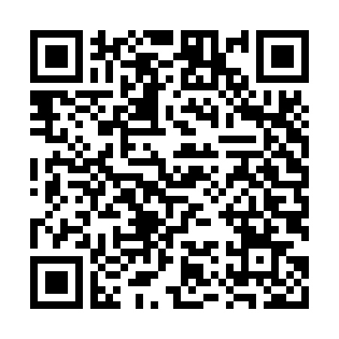
A little about us... Sheryl has over 30 years of teaching experience in grades
K – 4 at Linder, Cunningham, Gullett and Hill Elementary. She has a BS in education and a M.Ed. from The University of Texas at Austin. Her certifications are in the following areas: general elementary, reading specialist, and English as a second language. She is also a National Board Certified Teacher. She enjoys reading, gardening and spending time with her granddaughter, Ayla.

Katherine has 24 years of teaching experience in grades Pre-K – 5 at Burrus Elementary in Houston and Ridgetop, Casey, Gullett and Hill Elementary in Austin She has also taught in private schools. She has a BA from the University of Houston in journalism and is certified to teach early childhood - 6th grade and English as a second language. She is married and has a daughter at Lamar Middle School and a son at McCallum High School.

We are excited about the opportunity to team teach to give your child the best possible education this year. Working together will enable us to concentrate on the subjects we teach. Sheryl will focus on math and science. Katherine will focus on reading, writing and social studies. We highly value the classroom community that is created when children spend the whole day with one teacher. This is the reason we will treat both our classes as one big class, “The Brainy Bunch,” and spend a portion of each day all together. (recess, read aloud time, etc.) The majority of instruction will take place in smaller groups.

We both believe that instruction needs to be both meaningful and enjoyable to children for optimal learning to occur. Dr. Renate Caine, an expert in the area of brain research, says that, “Emotions are like the window or door to the brain, they can open or close the door to learning.” We agree that emotional well being plays an important role in learning and strive to make our classrooms a place in which children will look forward to spending time.

Your child will be bringing home a plastic folder from school each day that will serve as the basis of home - school communication. It will contain any papers that need to be sent home along with a short note from your child about his/her school day. We encourage you to write a short note back to your child if possible.

